**Task 21**

Create a S3 bucket, with no public access and upload files to the bucket

**Creating S3 bucket**

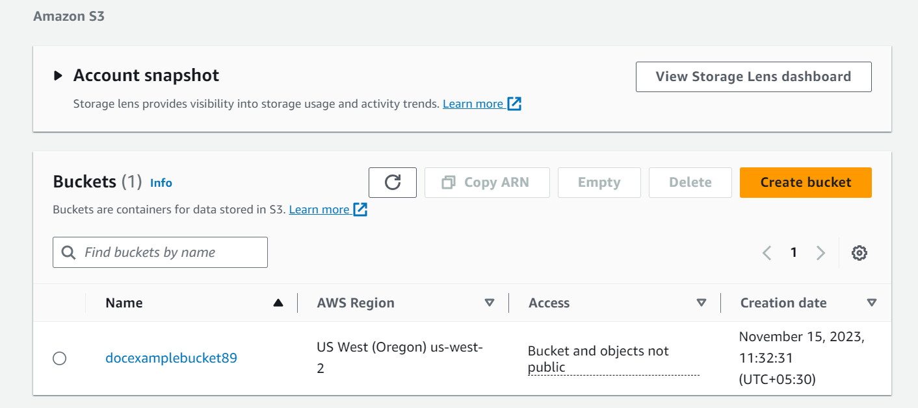

**Uploaded file to the bucket**

